EXP 7 FIFO using VHDL
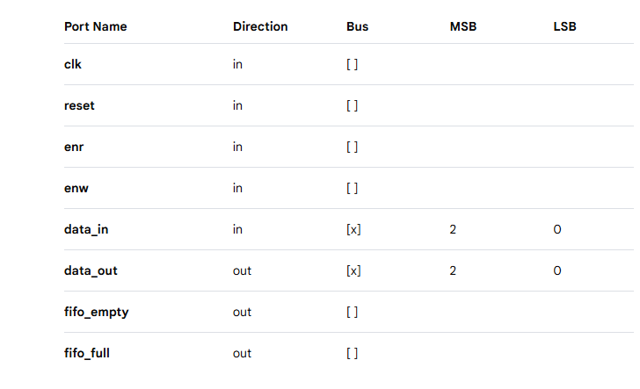

library IEEE;
use IEEE.STD_LOGIC_1164.ALL;
use IEEE.NUMERIC_STD.ALL;
use IEEE.STD_arith_.ALL;
use IEEE.STD_unsigned_.ALL;

entity fifo is
generic (depth : integer := 8);
port (
clk : in std_logic;
reset : in std_logic;
enr : in std_logic;
enw : in std_logic;
data_in : in std_logic_vector (2 downto 0);
data_out : out std_logic_vector(2 downto 0);
fifo_empty : out std_logic;
fifo_full : out std_logic
);
end fifo;

architecture Behavioral of fifo is

type memory_type is array (0 to depth-1) of std_logic_vector(2 downto 0);
signal memory : memory_type := (others => (others => '0'));

signal readptr, writeptr : integer range 0 to depth-1 := 0;
signal empty, full : std_logic := '1';
signal dataout : std_logic_vector(2 downto 0);
signal count : integer range 0 to depth := 0;

begin

fifo_empty <= empty;
fifo_full <= full;
data_out <= dataout;

process(clk, reset)
begin
if(reset = '1') then
dataout <= (others => '0');
readptr <= 0;
writeptr <= 0;
count <= 0;
empty <= '1';
full <= '0';

elsif rising_edge(clk) then

-- WRITE
if(enw = '1' and full = '0') then
memory(writeptr) <= data_in;
if(writeptr = depth-1) then
writeptr <= 0;
else
writeptr <= writeptr + 1;
end if;
count <= count + 1;
end if;

-- READ
if(enr = '1' and empty = '0') then
dataout <= memory(readptr);
if(readptr = depth-1) then
readptr <= 0;
else
readptr <= readptr + 1;
end if;
count <= count - 1;
end if;

-- FLAGS
if(count = 0) then
empty <= '1';
else
empty <= '0';
end if;

if(count = depth) then
full <= '1';
else
full <= '0';
end if;

end if;
end process;

end Behavioral;

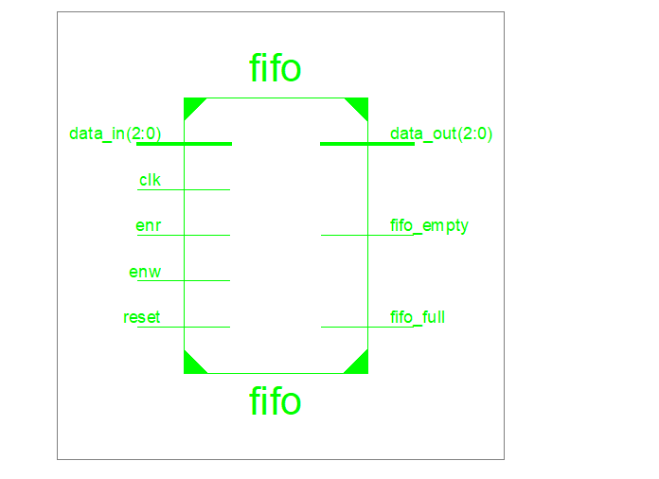

Test Bench Code
library ieee;
use ieee.std_logic_1164.ALL;
use ieee.numeric_std.ALL;

entity fifo_tb is
end fifo_tb;

architecture behavior of fifo_tb is

-- Inputs and outputs
signal Clk, reset, enr, enw : std_logic := '0';
signal fifo_empty, fifo_full : std_logic;
signal data_in, data_out : std_logic_vector(2 downto 0) := (others => '0');

-- Clock period definitions
constant Clk_period : time := 10 ns;
constant depth : integer := 8;

begin

-- Instantiate the Unit Under Test (UUT)
uut: entity work.fifo
generic map (depth => depth)
port map (
clk => Clk,
reset => reset,
enr => enr,
enw => enw,
data_in => data_in,
data_out => data_out,
fifo_empty => fifo_empty,
fifo_full => fifo_full
);

-- Clock process
Clk_process : process
begin
Clk <= '0';
wait for Clk_period/2;
Clk <= '1';
wait for Clk_period/2;
end process;

-- Stimulus process
stim_proc: process
begin

-- Apply reset
reset <= '1';
wait for Clk_period;
reset <= '0';
wait for Clk_period*2;

-- WRITE (fill FIFO)
enw <= '1';
enr <= '0';
for i in 1 to depth loop
data_in <= std_logic_vector(to_unsigned(i,3));
wait for Clk_period;
end loop;

-- STOP WRITE
enw <= '0';
wait for Clk_period;

-- READ (empty FIFO)
enr <= '1';
for i in 1 to depth loop
wait for Clk_period;
end loop;

-- STOP READ
enr <= '0';

wait;
end process;

end behavior;
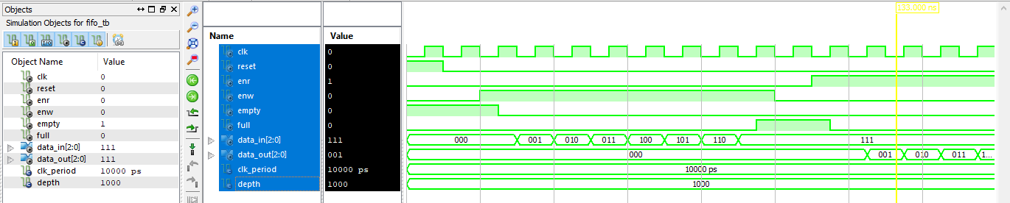

Implementation Code
library IEEE;
use IEEE.STD_LOGIC_1164.ALL;
use IEEE.NUMERIC_STD.ALL;

architecture Behavioral of fifo is

type memory_type is array (0 to depth-1) of std_logic_vector(2 downto 0);
signal memory : memory_type :=(others => (others => '0'));

signal readptr,writeptr : integer := 0;
signal empty,full : std_logic := '0';

signal temp:std_logic_vector(27 downto 0);
signal sclk:std_logic;

signal dataout:std_logic_vector(2 downto 0); -- ✅ fixed

begin

p11: process(clk,reset)
begin
if(reset='1') then
temp <= (others=>'0');

elsif rising_edge(clk) then
temp <= std_logic_vector(unsigned(temp) + 1); -- ✅ fixed
end if;
end process;

sclk <= temp(27);

end Behavioral;
Constraint File Code. Ucf

NET "clk" LOC = "L15" | IOSTANDARD = LVCMOS33;
NET "reset" LOC = "E4" | IOSTANDARD = LVCMOS33;

NET "enr" LOC = "T5" | IOSTANDARD = LVCMOS33;
NET "enw" LOC = "R5" | IOSTANDARD = LVCMOS33;

NET "data_in<0>" LOC = "A10" | IOSTANDARD = LVCMOS33;
NET "data_in<1>" LOC = "D14" | IOSTANDARD = LVCMOS33;
NET "data_in<2>" LOC = "C14" | IOSTANDARD = LVCMOS33;

NET "data_out<0>" LOC = "U18" | IOSTANDARD = LVCMOS33;
NET "data_out<1>" LOC = "M14" | IOSTANDARD = LVCMOS33;
NET "data_out<2>" LOC = "N14" | IOSTANDARD = LVCMOS33;

NET "fifo_empty" LOC = "P16" | IOSTANDARD = LVCMOS33;
NET "fifo_full" LOC = "D4" | IOSTANDARD = LVCMOS33;

